### 

### **1. Introduction**

Runnerly is a community-driven mobile application designed to inspire users to stay active, improve their fitness, and achieve personal running goals. Whether you're a beginner taking your first strides or a seasoned runner pursuing daily consistency, Runnerly empowers users to track their journey and challenge their limits.

At its core, Runnerly offers intuitive features to log every run manually capturing essential details such as date, distance, and duration. Users can instantly view performance summaries including total distance, total time, and average pace, displayed with bold visual elements on a stylish dark-themed dashboard. Weekly statistics and recent run activity ensure users stay engaged and accountable.

Beyond simple tracking, Runnerly introduces a dynamic challenge system where users can participate in time-bound goals like "Run 50 km in 10 days" or "Daily 5K Streak for a Week."

This gamification encourages consistent progress while rewarding achievements. All of this is presented through a polished UI with orange-accented buttons, rounded cards, and strong typography for readability. Profile pages showcase user identity, total accomplishments, and running milestones to reinforce motivation.

Runnerly’s mission is simple: to help people move more, track better, and challenge themselves with every run.

### 

### **2. Contents**

In this test project there are some files and usable resources:

1. Mobile_TP.pdf (Test project file)

2. Mobile_Style.pdf (Style guide file)

3. Backend API (Folder that contains the API executables)

4. Resources (Usable resources folder)

### 

### **3. Project Description and Tasks**

You are tasked with building the **first phase** of the Runnerly app which focuses on the **running log** and **challenge completion tracker**. The backend team has provided a functional REST API, and all API specifications can be accessed via Swagger at:

* http://localhost:5000/

**Project Name Format**: RunnerlyXX, where XX = your PC number.

### 

### 

### **4. Application Screens and Features**

#### **1. Login & Register Screen**

* User can log in using email and password.
* Register screen includes validation:  
  + Password should be shown as mask (not plain-text).
  + Email must be unique.
  + Age must be > 13 years old.
  + Password length ≥ 6.

#### 

#### 

#### **2. Home Screen**

Displays summary information for the user:

* Total Distance Run (this week)
* Average Pace (min/km)
* Total Duration Run (this week)
* Show “Last recent runs” data
* When user click “This Week” panel, navigate to “**My Runs Screen**”
* Button Log Run navigate to "**Log Run Screen**" and Button Challenges navigate to "**Challenges Screen**"
* Button to logout will redirect into the “**Login Screen**”

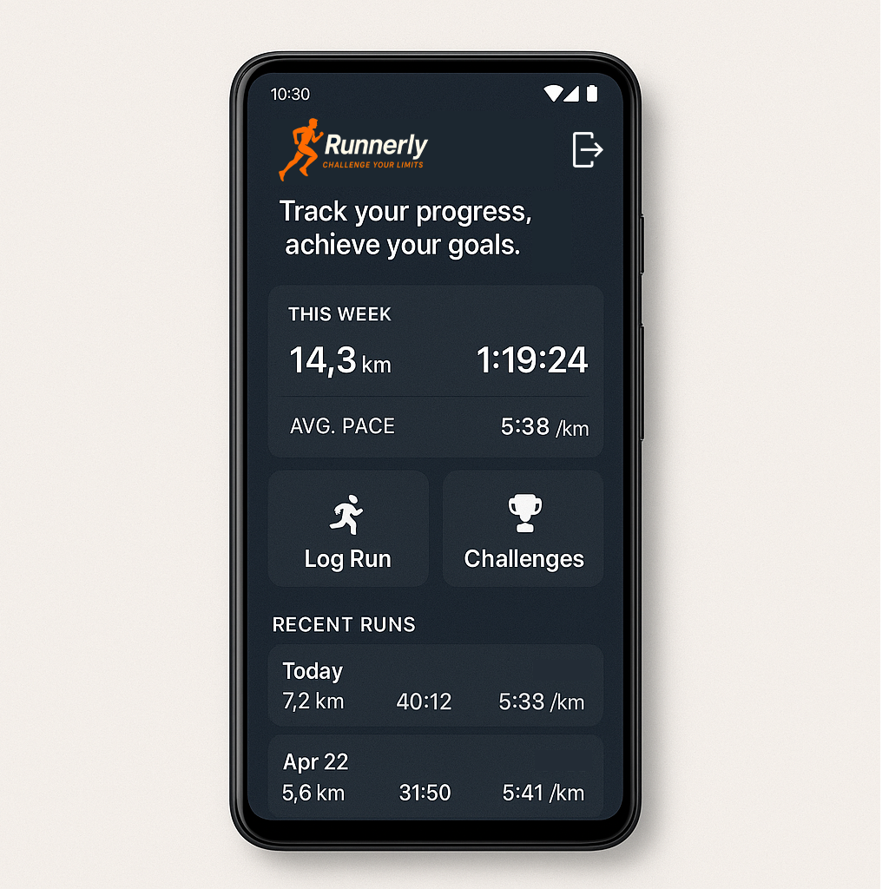

#### 

#### **3. Log Run Screen**

User manually logs their run.

* Fields:  
  + Date of run, set today date by default with format MMM DD, YYYY
  + Distance (km) → must be positive number (support decimal)
  + Duration (HH:MM:SS)
* Calculates and displays:  
  + **Average pace = Duration / Distance**
* On submit, the run is added to their history and challenge tracker is updated.
* Back button navigate to “**Home Screen**”

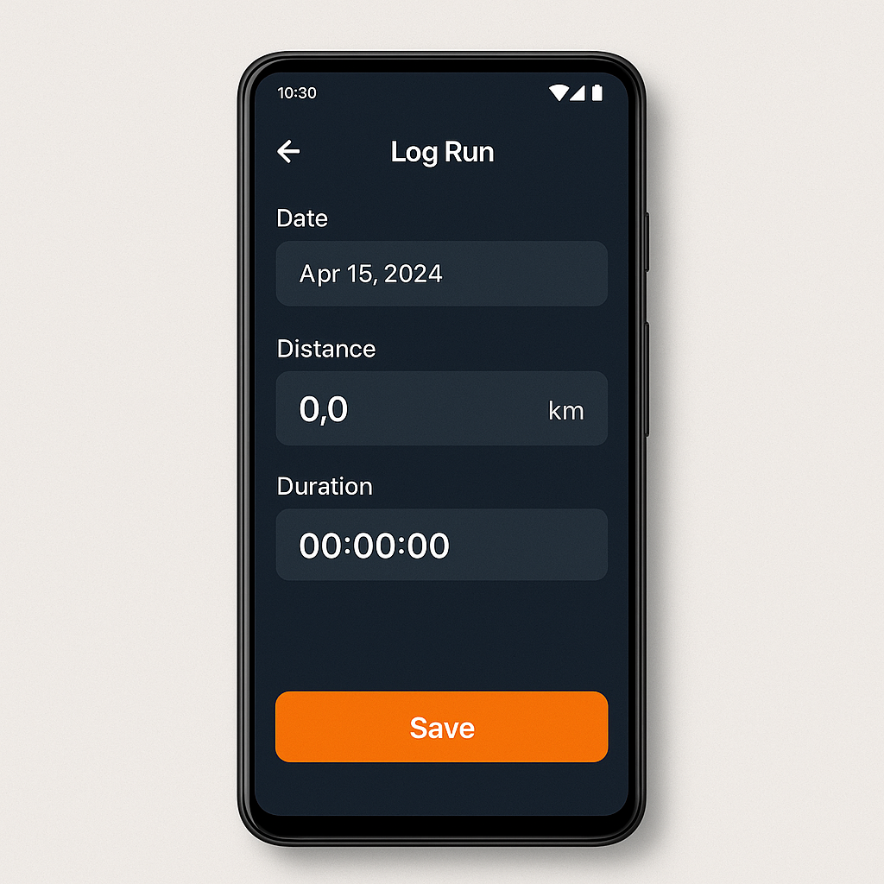

#### 

#### **4. My Runs Screen**

Displays list of previous runs.

* Each item shows:  
  + Date (MMM DD, YYYY)
  + Distance
* Filter by Date range (Start and End date).
* Sort by newest run first.
* Back button navigate to “**Home Screen**”

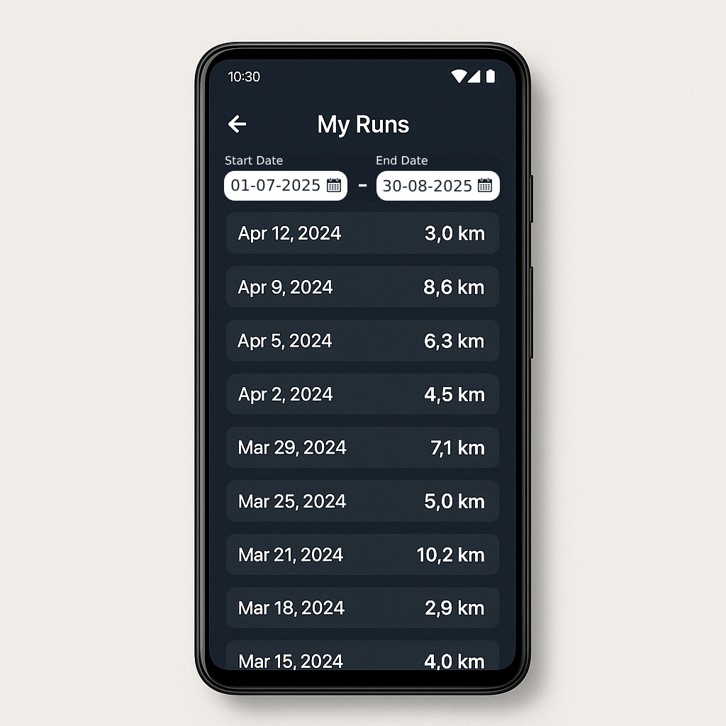

#### 

#### **5. Challenges Screen**

Displays all active challenges:

* Each challenge has:  
  + Title (e.g., “Run 50 km in 10 days”)
  + Description
  + Target Distance & Deadline
* Button leaderboard will redirect to “**Leaderboard Screen**” in selected Challenge.
* Back button navigate to “**Home Screen**”

#### 

#### **6. Leaderboard Screen**

* Leaderboard screen page:  
  + In Leaderboard will showing all participants joined challenges
  + Showing their % completion with progress bar
  + Completed challenges are shown with a trophy icon
* Back button navigate to “**Challenges Screen**”

